Spotipy Installation Instructions

1. Install spotipy using pip or easy install
2. Navigate to: <https://developer.spotify.com/dashboard>
   1. Login
   2. Click ‘Create A Client ID’
      1. Name the app whatever you want
      2. Give it a description
      3. Click the ‘Desktop App’ checkbox
      4. When asked if you are developing a commercial integration click ‘no’
      5. Check all three of the ‘I Agree’ checkboxes and then click ‘Submit’
   3. Open your new app 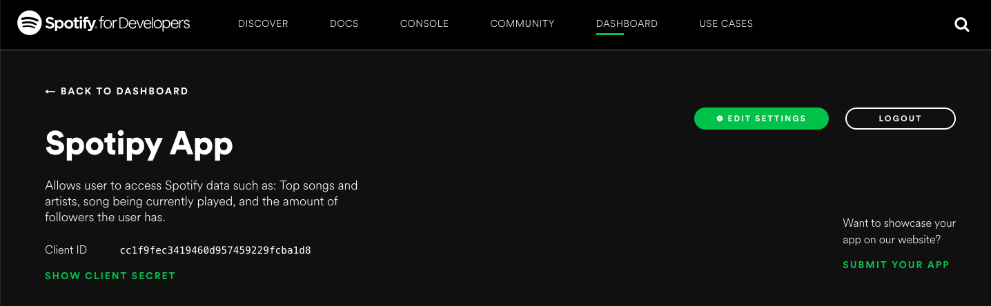
      1. Click ‘Edit Settings’
      2. Under ‘Redirect Uri’ type: <http://google.com/>
      3. Click ‘Save’
3. Navigate to spotify.py
   1. In the try and except block copy and paste your Client ID and Client Secret that are on your app at <https://developer.spotify.com/dashboard>

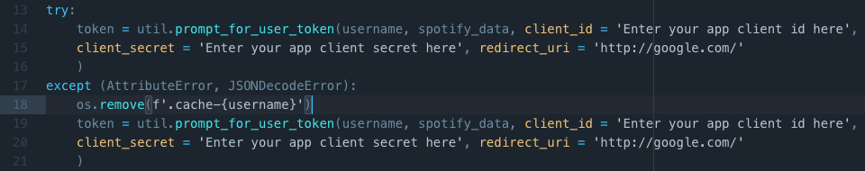

1. Open Terminal/command line. Type: python spotify.py [Your Spotify user ID]
   1. You will be redirected to a new google window. Copy the link that is in the address bar and paste it into the terminal/command line.
      1. The program will then start